**Profit and Loss Derivations :-**



User customer consumer

**1) Based Price/Gross Price :-**

Base price:- Price without any additional charges (pre-tax).

Gross price:- Final price including taxes, fees, etc. (post-tax).

Example :- 30 $

**2) Pre_invoice deductions :-**

* Usually it is in %.

Yearly discount agreement made at the beginning of the fic year.

Example : 2 $

Then Gross price - pre-invoice deduction = Net invoice Sales

**30$ - 2$ = 28$**

**Offers:**

1. **Promotional offers :** let say any festival example diwali and dussehra, then Atliq provide some offers to the customer called **promotional offers**.
2. **Placement fee** :- let say if the Atliq informs the customer to place their products in the prime location for more attraction then they will provide some discount or fee for the maintenance called **placement fee.**
3. **Performance Rebate :-**  let say the particular customer does huge sales to the unit then they provide some offers called **performance Rebate.**

**3) Post - invoice deductions : offers - fee - rebate-**

**Example :- 3 $ ( mostly it is in %).**

**Net Invoice Sales - Post - invoice deductions = Net Sales.**

**28 $ - 3 $ = 25 $**

**Net invoice sales * post invoice pct = post invoice amount**

**4) Net Sales :-** Net sales refers to the total revenue from sales after deducting.

Net Sales=Gross Sales − Returns − Allowances − Discounts.

**5) Cogs** :- **(** **Manufacturing cost + Transportation cost( freight cost ) + other cost** **) = 20 $**

* Their might be 10 to 15 costs are associated with cogs
* COGS is subtracted from net sales to calculate the gross profit,

**Net Sales * freight _ Pct = freight cost**

**Net_sales * other freight _pct = other freight cost**

**6) Gross Margin :**

* % of revenue retained by the company after the deductions.
* is often used to evaluate profitability.

**NET SALES - COGS = GROSS MARGIN (PROFIT)**

**25 $ - 20 $ = 5$**

**Gross margin %of net sales ( GM / NS ) :-**

**(( Net sales - cogs ) / net sales )*100)**

**((25 - 20 ) / 25 )*100) = 20**

**7) Net Profit :-**

**Gross Margin - ( operational cost ) = Net Profit**

**Operational cost :- Net sales * operational _pct = operational amount (ass , papers)**

**Operational other pct : Net sales * operational _pct = operational amount ( current bill, renst and**

**so.)**

**8) NDIVIDE([Net Profit $], [NS $], 0)**

**How were we picking data for data analytics ?**

* Any organisation lets say amazon , they might have different data based to keep their daily transactions example, survey monkey for surveys,could,RBMS and so.
* As a data analyst we are not directly hit the main database and collect the data, if we do so, we might be the reason , to slow down the process.
* As Data engineer he talks with the real databases and do the ETL mechanism and place the hole data into data ware houses.
* DS/DA we can hit the DW and do the necessary things.

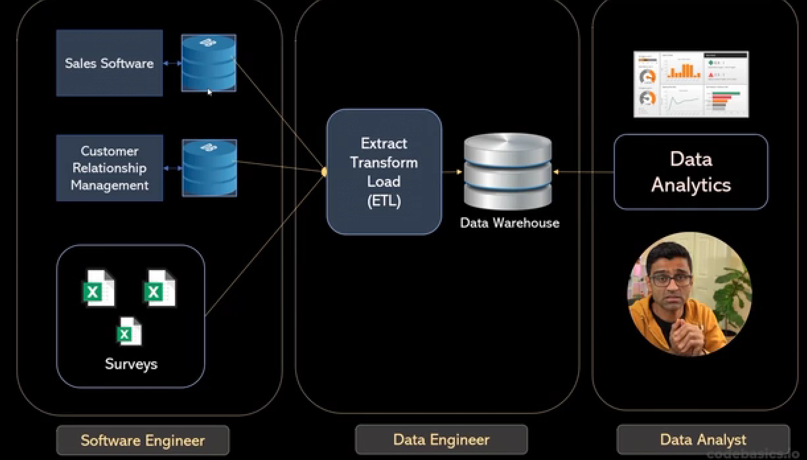

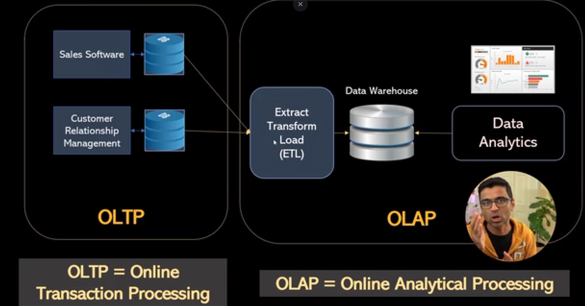

**OLAP (Online Analytical Processing)**: Used for complex data analysis and decision-making, focusing on historical data and reporting.

**OLTP (Online Transaction Processing)**: Used for managing real-time transactional data, focusing on fast, day-to-day operations like order processing or inventory updates.

**Data catalogue** :- information / data set where we can find the data based and their data engineer.

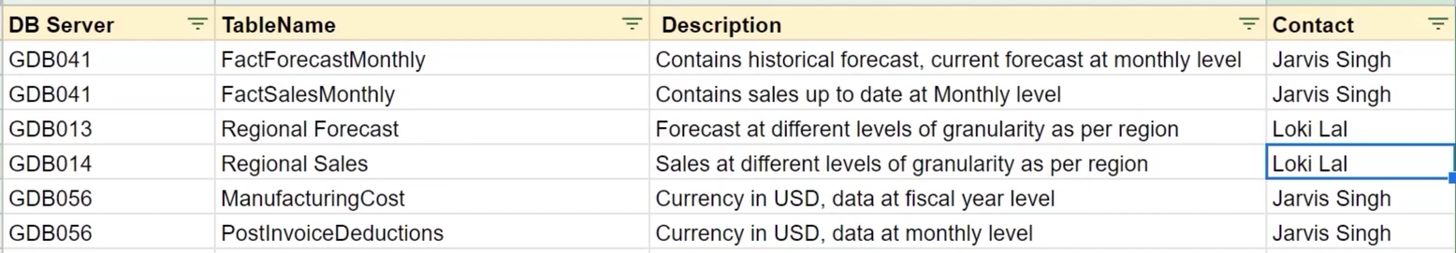

**Data Information :-**

1. **Channel :-**

